Guide to Super-resolution Imaging

Primary Contacts:

Prof. Keith A. Lidke, [klidke@unm.edu](mailto:klidke@unm.edu)

Sajjad Khan, [sajjadkhan@unm.edu](mailto:sajjadkhan@unm.edu)

Department of Physics and Astronomy

Lab: Room 2409 of the PAIS building (210 Yale Blvd NE)

<http://panda3.phys.unm.edu/~klidke/>

**Overview**

We can advise on preparing samples and will collect image data and help interpret results. To get started, consult this guide, then contact Sajjad and Keith.

Table of Contents

Background

Super-resolution imaging

Labeling methods

Secondaries are more time consuming in labeling and are upto 15 nm away from protein. If using secondary labeling, do that in first round.

SR Imaging Workflow

Getting started

Optimize labeling

Prepare samples for imaging

SR imaging

Analysis

Data

Large projects and advanced training

Recommended protocols

Fixing and labeling of cells

Labeling of primary antibodies

Instruments

Data will be collected on one of these microscopes.

Total Internal Reflection Fluorescence (TIRF) Microscope

Sequential Super-resolution Microscope

Authorship and funding acknowledgements

# 

# Background

The K. A. Lidke lab develops new optical techniques that are able to probe cellular structure and dynamics at or close to the molecular scale. Our developed technology includes fluorescence super-resolution techniques, single particle tracking and high-speed hyperspectral microscopy. The Lidke lab has served as the STMC Super-resolution Imaging Technology Core, through which we have made our technology available to STMC members and others. The Lidke lab is dedicated to applying our technology to help study biological processes and we are happy to now team up with the AIM center to help apply super-resolution imaging to the study of autophagy, inflammation and metabolism.

## Super-resolution imaging

In light microscopy, super-resolution imaging implies techniques which allow images to be taken with a higher resolution than the one imposed by the diffraction limit. The approaches followed at K. A. Lidke lab for super-resolution imaging is called single-molecule localization microscopy (SMLM). This includes techniques like Direct Stochastic Optical Reconstruction Microscopy (dSTORM), Photoactivated Localization Microscopy (PALM) and DNA-based point accumulation for imaging in nanoscale topography (DNA-PAINT).

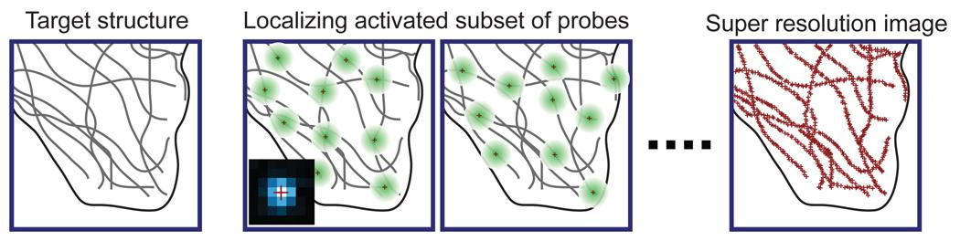

Fig. Cartoon showing principle of single molecule localization microscopy [1].

The two former techniques make use of the photochemical properties of the fluorophore to induce a weakly emissive or non-emissive “dark” state. During imaging a very small population of fluorophore is stochastically brought back from the dark state, excited using a laser, and detected. This shows up as “blinking” fluorescence in the collected image sequence. The detected images are then statistically analyzed to determine the location of single fluorophores with a level of precision scaling with the number of detected photons. On determination of location of every fluorescent molecule in the sample, a super-resolution image of the sample is reconstructed with approximately 10–30 nm lateral resolution.

In DNA-PAINT, transient binding of short dye-labeled (imager) oligonucleotides to their complementary target (docking) strands creates the “blinking” to enable stochastic super-resolution microscopy. The docking strands are conjugated to antibody and used as tags for the subcellular structure to be imaged. The imager strands are allowed to diffuse in the medium on the sample and on hybridisation to docking strand are detected in the collected image sequences. The image sequences are processed as detailed above to reconstruct the super-resolution image of the sample.

**References**

1. B. Huang, M. Bates and X. Zhuang, ‘Super resolution fluorescence microscopy’, Annu. Rev. Biochem. (2009) **78**, 993.

## Labeling methods

## 

## For super-resolution imaging, we recommend using fluorophore conjugated primary antibodies for immunolabeling of subcellular structures. This approach has advantages like shorter sample staining time, a simpler workflow and less background fluorescence from non-specific binding. However, if commercially labeled direct conjugates are unavailable or if fluorophore conjugation of primary antibody is not feasible, indirect immunolabeling with secondary antibodies can also be used. This approach is more time consuming for labeling and could also have the fluorophore upto 15 nm away from protein.

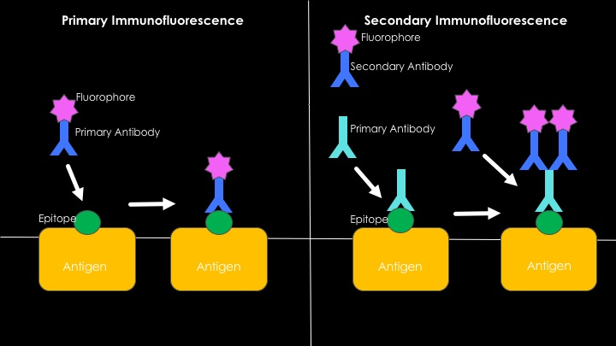

Fig. Cartoon showing direct and indirect immunofluorescence labeling using antibodies [2].

## For multi-target super-resolution imaging using sequential approach, the immunolabeling scheme should be optimized so that the least abundant target is imaged first and the most abundant one the last. This allows minimal chances for cross-talk between the different rounds of imaging. It is also recommended that secondary antibody labeling (if being employed) be restricted to the target being imaged in the first round.

**References**

2. Wikipedia entry on Immunofluorescence (https://en.wikipedia.org/wiki/Immunofluorescence).

# SR Imaging Workflow

## Getting started

Potential collaborator contacts Dr. Keith Lidke and discusses the scientific problem where super-resolution imaging could be beneficial. Technical feasibility concerns regarding the imaging experiment are sorted out during this process. This typically includes helping to determine a labeling scheme that would best suit the super-resolution imaging needs in the study. With input from the collaborator, we then schedule the microscope for imaging on an agreed upon date and time.

## Optimize labeling

Before going ahead with super-resolution imaging of samples, it is important for the collaborator to optimize the labeling protocol (in keeping with previously agreed upon scheme) for each cellular structure to be imaged. We recommend imaging samples with a confocal microscope (eg. at UNM Fluorescence Microscopy Shared Resource) and making sure that cell structures to be imaged look good in immunofluorescence. It is also recommended that the collaborator share these confocal images with us.

## Prepare samples for imaging

The collaborator prepares the sample according to the optimized fixing/labeling protocol and gets the sample ready for imaging on the scheduled date. Please provide us with either:

1. Cells immunostained for each structure independently, and
2. Cells immunostained for all structures (multi-color).

Or

1. Cells immunostained for first structure to be imaged, along with the optimized staining protocol for the next structures (in the case of sequential imaging).

It is recommended that samples be brought to and stored in refrigerator at room 2403 the evening before the scheduled imaging session. If that is not possible, please have the samples brought over to room 2403 at least 10 minutes before the scheduled imaging time. Key requirements for the sample are:

1. Super-resolution imaging is performed using high-NA objectives with small working distances. So, it is essential that samples are prepared on **#1.5 coverslip glasses**, either 25mm round or 8-well chambers. Please see the ‘Supplies and Reagents’ section for manufacturer details and catalog numbers.
2. For successful super-resolution imaging, it is essential that samples **do not** have floating cell fragments (or any other substances) in the buffer. To this end, please adhere to the recommended fixing/labeling protocol.
3. For sequential super-resolution imaging, the recommended fluorophore for immunostaining is AlexaFluor-647. We do keep a stock of anti-mouse, anti-rabbit and anti-GFP secondary antibodies conjugated to AlexaFluor-647, which can be used if needed. In case the collaborator prefers to make use of DNA-PAINT imaging, we also keep a stock of anti-mouse and anti-rabbit secondary antibodies with DNA-PAINT docking oligonucleotides and their corresponding imager oligonucleotides conjugated to AlexaFluor-647 or ATTO-655.

## 

## SR imaging

We perform imaging on the sample during the scheduled time. For sequential imaging of multiple subcellular structures in the sample, collaborator provides us with any reagents/antibody needed and the optimized protocol. Collaborators are welcome to stay during the imaging and help us with the re-labeling steps.

## Analysis

The data collected from the imaging session consist of large sequences of fluorescence images (often running into several gigabytes per cell). We perform post-acquisition analysis on these images to determine positional coordinates of individual fluorescent molecules in the cell. These coordinates are then used to reconstruct the super-resolution fluorescence image of the cellular structure being imaged.

In the case of sequential super-resolution imaging of multiple cellular structures, we also create multi-color colocalization images. Further statistical analysis can be done on a case-by-case basis, the terms of which can be discussed with Dr. Keith Lidke.

## Data

Data are stored locally on storage drives. These data are also backed up regularly to network storage systems for longer term storage. However, the storage spaces are limited in capacity and owing to the large size of data collected, we often run out of space. So we recommend that collaborators let us know when the data has been copied or completely utilized, so that they can be deleted from the local drives.

# Large projects and advanced training

For large projects that are expected to take numerous sessions of imaging it could be useful for the collaborator (or someone else directly associated with the project) to take the leading role in super-resolution imaging. In such cases, a training session on Laser safety and effective usage of the microscope is needed before the collaborator is allowed unsupervised/independent use of the imaging instruments. Please contact Sandeep Pallikkuth to schedule the training session. On successful completion of the training, access is also granted to an online calendar for the collaborator to schedule imaging.

# 

# Recommended protocols

# 

## Fixing and labeling of cells

**Inventory**

*Coverslip glass*: 25 mm #1.5 round

*Blocking solution*: 5% BSA, 0.05% Triton X-100, PBS

*Wash solution*: 2% BSA, 0.05% Triton X-100, PBS

**Plating cells**

1. 25mm (#1.5) coverslip glasses are washed with 0.1% microquot soap, rinsed well and boiled in ddH2O to remove lipid/protein debris. They are then dried and autoclaved.

2. Cells are plated (200,000 cells per coverslip glass) in 6 well chambers and let adhere overnight.

**Fixing and Labeling**

1. The cells are washed once with 1 mL PBS.

2. Two step fixation:

1. 0.6% PFA - 0.1% GA - 0.25% Triton X-100 (1mL in PBS) for 60 seconds
2. 4% PFA - 0.2% GA (1mL in PBS) for 1.5 to 2.5 hrs.

3. Wash 2x with 1 mL PBS.

4. Treat with 0.1% NaBH4 (1 mL in PBS) for 5 minutes at room temperature.

5. Wash 2x with 1 mL PBS.

6. Treat with 10 mM Tris (1 mL in PBS) for 2x5 minutes at room temperature.

7. Wash 2x with 1 mL PBS.

8. Block in blocking solution (1 mL) for 15 minutes.

9. Wash once with PBS.

10. Label with the desired concentration of AlexaFluor-647 conjugated antibody in wash-solution for 1 hour at room temperature.

11. Wash with wash-solution (1 mL) for 3 x 5 minutes at room temperature.

12. Wash once (1mL) and store in PBS at 4⁰C.

## Labeling of primary antibodies

We recommend that you purchase primary antibodies pre-conjugated with AlexaFluor-647. Example resources for many good labeled primary antibodies are Novus Biologicals (https://www.novusbio.com) or abcam (https://www.abcam.com). If the labeled primary is not available, conjugation can be performed using amine-reactive AlexaFluor-647 following the protocol given below.

**Inventory**

1. 100 mL of primary antibody with concentration 1 mg/mL
2. Alexa Fluor 647 in DMSO, volume calculated for a 7:1 dye to primary antibody ratio
3. NaHCO3, volume calculated for a final concentration of 100 mM
4. ProSpin Column (CS-800, Princeton Separations)
5. Amicon Ultra centrifugal filter (UFC510024, Sigma Aldrich)

**Antibody Purification**

Sometimes stock antibody might contain salts, stabilizing proteins (e.g. BSA) or low molecular weight substances such as sodium azide which can impact the dye conjugation efficiency. In such cases, it may be necessary to purify the antibody prior to carrying out the labeling reaction.

Purification using Amicon Ultra centrifugal filter:

1. Dilute antibody to 500 uL with 1xPBS and apply to Amicon device.

2. Centrifuge at 14,000 x g in fixed angle rotor Eppendorf centrifuge for 10 min. Make sure the filtering membrane of the Amicon device faces outward.

3. Retrieve sample by flipping the filter upside down in a clean tube and centrifuge at 1,000 x g for 2 min

4. Measure concentration using UV spectroscopy (e.g. NanoDrop).

**Antibody Conjugation**

1. Prepare ProSpin column:

a. Hydrate the columns by gently tapping the columns to ensure that the dry gel has settled to the bottom of the column. Remove the top column caps and reconstitute all columns by adding 650 uL of 1xPBS.

b. Replace the column cap and vortex vigorously for about 5 seconds. Remove air bubbles by sharply tapping the bottom of the columns. Allow at least 30 min of room temperature hydration time before using the columns.

2. Mix primary antibody, Alexa Fluor 647 and NaHCO3 solution on stir plate for 1 hr. at room temperature.

3. Remove top column cap and column end stoppers of prepared ProSpin column. Spin the column in wash tube with a variable speed centrifuge at 750 x g for 2 min to remove excess fluid.

4. Transfer the antibody-dye-mixture to the top center of the gel column. Be careful to not touch the gel or the sides of the column with the pipet tip.

5. Place column in a collection tube and spin for 2 min at 750 x g. Purified sample will collect in the bottom of the collection tubes. Discard the spin columns.

6. Measure the antibody to dye concentration ratio performing NanoDrop spectrometer measurement (A280 and Adye).

**Supplies and Reagents**

***Microscope sample supplies***

25 mm #1.5 coverslip glass: Warner Instruments, Catalog No. CS-25R15

8 well chamber: Thermo Scientific Nunc, Lab-tek II chambered coverglass, Catalog No. 155409

***Filtering Systems***

ProSpin Column: Princeton Separations, Catalog No. CS-800

Amicon Ultra centrifugal filter: Sigma Aldrich, Catalog No. UFC510024

***Chemicals***

PFA: Electron Microscopy Sciences, Catalog No. 15710

GA: Electron Microscopy Sciences, Catalog no. 16020

NaBH4: EMD Millipore, Catalog No. 806373

Tris: EMD Millipore, Catalog No. 9210

Triton X-100: EMD Millipore, Catalog No. 9410

NaHCO3: Mallinckrodt Chemicals, Catalog No. 7412-06

PBS: ThermoFisher Scientific, Catalog No. 10010023

# 

# Instruments

## At K. A. Lidke lab, super-resolution imaging data is collected on one of the below described microscopes.

## 

## Total Internal Reflection Fluorescence (TIRF) Microscope

Location: Room 2409, PAIS building

TIRF microscope is custom-built off an IX71 inverted microscope frame, capable of simultaneous epi-fluorescence detection in 4 different color channels spanning the visible wavelength range. Samples can be excited using a choice of 4 different laser lines that are fed into the microscope using optical fibers. Fluorescent images of the sample are acquired using an electron-multiplying charge-coupled device (EMCCD) camera, making it ideal for low signal application like single-molecule imaging. This microscope is also equipped with a *xyz* piezo stage for cell locating and brighfield registration. The instrument controls and image acquisition are computer controlled using custom-written software in MATLAB. Detailed parts-list is given below.

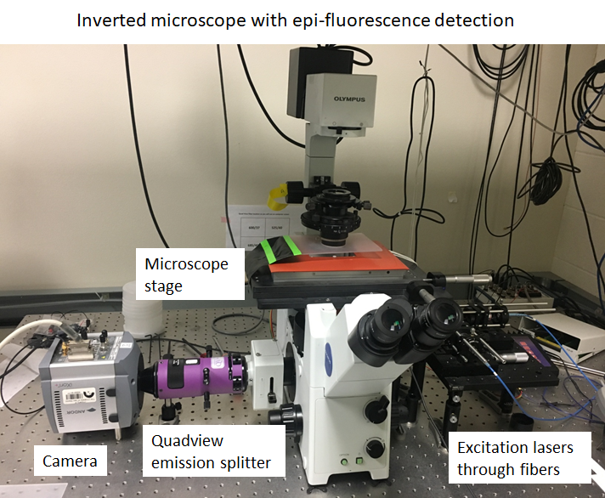

**Parts list as of 9/5/2018:**

Microscope frame: IX71, Olympus America Inc.

Objective: UAPON 150XOTIRF, Olympus America Inc.

*xyz* Piezo stage: Nano-LPS100, Mad City Labs

EMCCD camera: iXon 897, Andor Technologies

Quadview emission splitter: QV2-SQ, Photometrics

**Laser excitation:**

642 nm laser: laser diode HL6366DG, Thorlabs

561 nm laser: Sapphire 561-100, Coherent Inc.

488 nm laser: Newport PC15108, Spectra Physics

405 nm laser: DL405-010-O, Crysta Laser

Optical fiber: P1-488PM-FC-2, Thorlabs

**Emission detection:**

Quad-band dichroics: beamsplitters 1) T495 LPXR 2) T565 LPXR and 3) Q645 LPXR, AHF Analysentechnik

Emission filter: FF01-446/523/600/677-25, Semrock Brightline

Quadview filters: 1) 445/45, 2) 525/45, 3) 600/37 and 4) 685/40, Semrock Brightline

## Sequential Super-resolution Microscope

Location: Room 2409, PAIS building

The sequential super-resolution microscope is a custom-built multi-target super-resolution imaging system utilizing the sequential imaging strategy. This microscope is optimized for using photo-physical properties of the fluorophore ‘Alexa Fluor 647’ for each of the multiple targets being imaged, and images are recorded using a high quantum efficiency digital CMOS camera. This microscope is also equipped with automated re-finding of once registered cells and active image stabilization for nanometer scale drift correction while imaging. Computer control of the instrument is done using custom written MATLAB software. The detailed parts list is given below.

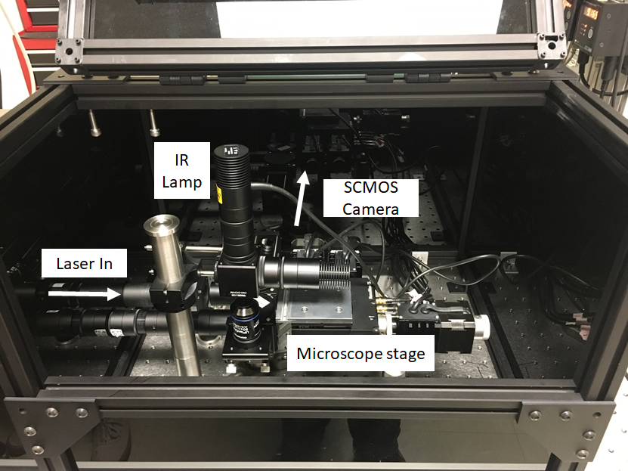

**Parts list as of 9/5/2018:**

Objective: APON 60XOTIRF, Olympus America Inc.

Microscope stage: MAX341/M 3-Axis NanoMax Stage, Thorlabs

Digital CMOS camera: ORCA -Flash4.0 V2 C11440-22CU, Hamamatsu

IR camera: DMK 31AU03, The Imaging Source

Focus lamp: 660nm M660L4, Thorlabs

IR lamp: 850nm M660L4, Thorlabs

**Laser excitation:**

647 nm laser: fiber laser, MPB Communications Inc.

405 nm laser: laser diode DL5146-101S, Thorlabs

Optical fiber: M105L02S-A, Thorlabs

Excitation filter: LD01-640/8-12.5, Semrock

Laser Speckle Reducer: 88-392, Optotune

**Emission detection:**

Emission filter: FF01-708/75-25, Semrock Brightline

IR filter: FF01-835/70-25, Semrock Brightline

IR Dichroic Mirror: FF750-SDi02, Semrock

# Authorship and funding acknowledgements

We appreciate proper acknowledgement in the publication of research work done in collaboration with K. A. Lidke lab. Acknowledgement for personal efforts can be in the form of co-authorship for Keith A. Lidke and Sajjad Khan (and Michael J. Wester if advanced analysis was performed).

It is also important to acknowledge funding resources for K. A. Lidke lab in publications. Please discuss with us as to use which of the grant details given below:

1. NIH grant supporting New Mexico Spatiotemporal Modeling Center (NIH P50GM085273)
2. NIH grant 1R21EB019589 (if sequential super-resolution imaging is used)
3. NIH grant supporting University of New Mexico Comprehensive Cancer Center fluorescence microscopy core (NIH P30CA118100) for Keith A. Lidke and Michael J. Wester.